Using the Binary Search Algorithm and trace table examples at the end of this document, complete the trace tables below for the Color Array. Upload this document to github and submit the link to your repository to the dropbox.

1st search: Violet

|  |  |  |  |
| --- | --- | --- | --- |
| **First** | **Last** | **Middle** | **Comparison** |
| 0 | 10 | 5 | Violet>Indigo |
| 6 | 10 | 8 | Violet>Red |
| 9 | 10 | 9 | Violet=Violet |
|  |  |  |  |
|  |  |  |  |

2nd search: Green

|  |  |  |  |
| --- | --- | --- | --- |
| **First** | **Last** | **Middle** | **Comparison** |
| 0 | 10 | 5 | Green<Indigo |
| 0 | 4 | 2 | Green>Chartreuse |
| 3 | 4 | 3 | Green>Dark Brown |
| 4 | 4 | 4 | Green=Green |
|  |  |  |  |

3rd search: Yellow

|  |  |  |  |
| --- | --- | --- | --- |
| **First** | **Last** | **Middle** | **Comparison** |
| 0 | 10 | 5 | Yellow>Indigo |
| 6 | 10 | 8 | Yellow>Red |
| 9 | 10 | 9 | Yellow>Violet |
| 10 | 10 | 10 | Yellow=Yellow |
|  |  |  |  |

**Color array**:

|  |  |
| --- | --- |
| aqua | [0] |
| brown | [1] |
| chartreuse | [2] |
| dark brown | [3] |
| green | [4] |
| indigo | [5] |
| lavender | [6] |
| magenta | [7] |
| red | [8] |
| violet | [9] |
| yellow | [10] |

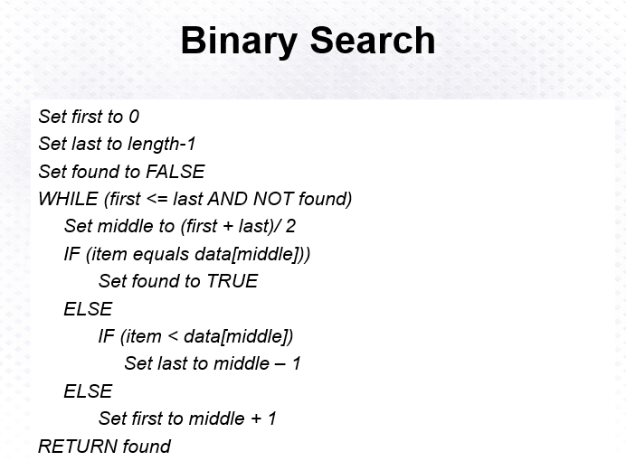

Above: Binary Search Algorithm

